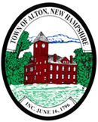

All town public meetings
will be remote
until further notice.

Unless otherwise posted

