The setting of the TAX RATE………….
The TAX RATE is determined by the amount of the tax levy (the amount of tax to be raised). Each year we start at ZERO.
First the town develops and adopts a budget. This is each monetary article on the ballot. Each monetary article has an estimated tax impact amount. (i.e. $0.02 per/1000)
Tax determination calculated by the Department of Revenue in November is based on the amount of appropriation approved at the March election that took place within the same calendar year and the estimated revenues from all sources reported on MS 434 for the current year. Revenues are subtracted from the original budget and remainder becomes the tax levy.
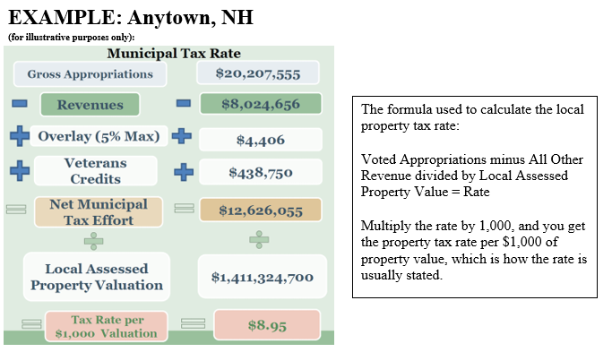
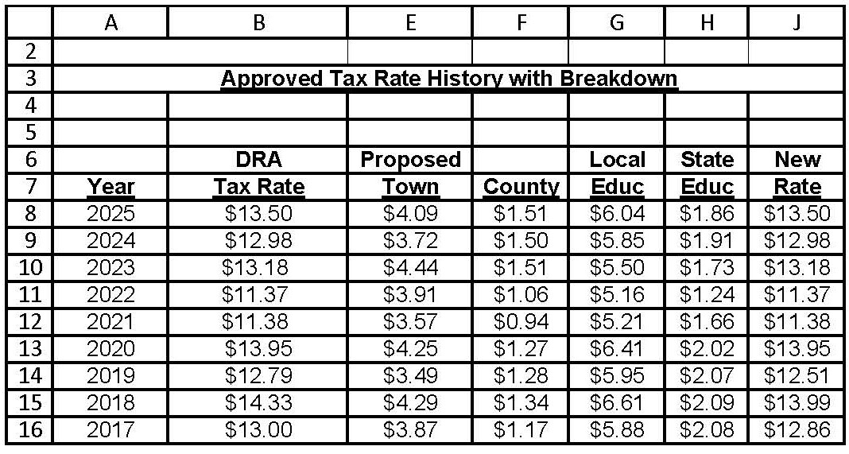
Alton’s Tax Rate History

